Will Friedrichs

CPLN 680

25 March 2022

Mid-Review Write-up

**Introduction/Motivation:**

City bus operations in Philadelphia have a variety of issues, but this report focuses specifically on two of them: i) buses arriving to and departing from stops early, and ii) buses that are cancelled in real-time, within hours of their original scheduled departure times. The scope of both issues may be examined by tracking data associated with all early bus departures and cancellations.

*Importance of Mapping Early and Cancelled Buses*

Early buses are troublesome because unlike cases of late buses, on-time riders likely miss their buses entirely. This is specifically detrimental in Philadelphia, where many buses only arrive every 20 minutes rather than in intervals of 5 or 10 minutes. Cancellations are similarly disruptive, but are also detrimentally not reflected by Google Maps Transit, a service used by thousands of Philadelphians every day to map their transit use. Currently, buses cancelled in real time are shown as scheduled to arrive on-time on Google Maps, treated similarly to an untracked yet still expected bus.

Early departures and real-time cancellations negatively affect the quality of the SEPTA bus experience for existing riders. Service quality has been repeatedly shown to be the most common complaint from regular bus riders across Philadelphia and other American transit systems, outpacing other concerns like fare rate (Cobau 2022), and dependability of network services is a key tenant of service quality. Many Philadelphia residents, especially those with lower incomes who depend on bus service for commutes and other regular trips. Being less able to pay for taxi and rideshare services, and less likely to have access to single-occupancy vehicles, low income residents are especially vulnerable to economic shocks associated with missed buses (lost jobs, child custody issues, etc.).

Both of these problems also discourage ridership growth by tainting potential regular riders’ first time impressions of the system. Riders that see the bus network as an one option but do have potential other ways to complete their trips have a higher bar for service quality. Generating more trips from higher income potential riders that fall into this category is crucial to establishing a resilient, equitable transit system that is viewed as the best way to get around rather than a “poverty option” reserved for the city’s most disadvantaged residents. If the demographic profile of residents with disproportionate influence in city governance is better represented in SEPTA ridership, that governance is more likely to push for improved transit experiences.

*Gaps in the Existing Data*

While early bus data is publicly accessible through Philadelphia’s real-time transit output feed, real-time non-GTFS Philadelphia bus cancellation data is not as accessible and has yet to be explored in a meaningful way. This report looks at both issues to uncover potential relationships between them, and to highlight the need for improvement. Additionally, while widely available public data streams have provided a steady flow of information about Philadelphia’s transit performance to the public, no public database has tracked performance over time in a public-facing way. This project aims to fill this void with a cumulative examination of early buses and cancellation data such that performance over time is tracked and recent issues are logged for public display.

*Personal Experience as a Motivating Factor*

In my own personal experience, early stops and real-time cancellations are the two issues that have had the most negative impacts on my own trips. Four days a week I take the 49 Bus from Spring Garden to University City, a 40 minute walking trip that takes around 20 minutes on a bus. Early buses, and especially cancelations that do not appear on Google Maps have caused me to miss my bus several times, turning my 20 minute bus into a walk that takes roughly twice as long. I also know of individuals who do not regularly take busses in the city, preferring to bike or drive purely because of the lack of reliability of city buses. With these questions in mind, along with the lack of substantial research specifically into geography of Philadelphia’s too-early and cancelled buses, brought me to the following questions.

**Question Definition:**

In tracking SEPTA bus early arrivals and real-time cancellations across routes, stops, and

times over the course of a month, which routes and stops are the most adversely affected? Are there patterns across days or weeks? Do the areas most affected by these problems correspond with the most disadvantaged communities? Do they correspond with routes having the lowest ridership?

For the purposes of this report, *early stops* will be defined as any stop that takes place three minutes or more before the scheduled stop time. *Real-time cancellations* will refer to any bus cancellations that are not specified as schedule alterations beforehand, specifically those whose “SEPTA real-time update” contains a cancellation notice.

**Literature Review:**

This literature review covers existing research into early bus arrivals and cancellation tracking, as well as the history of the use of GTFS formats by municipalities and transit agencies in the US.

*The nature of cancellations and delays in bus networks*

Kenneth A. Small conducted some of the first extensive rider surveys studying San Francisco area bus riders’ attitudes towards delays in bus networks in an era when American commuter delay research had been predominantly concerned with auto transit (Small 1982). While the ultimate negative results coming from trip cancellation and delay have long been apparent to researchers, more recent research has suggested early departures to be especially detrimental where buses are infrequent due to the greater costs of missing a bus in those circumstances (Currie et al. 2011). Given the comparatively high number of bus routes in Philadelphia with frequencies of 20 minutes or more, early buses seem to be an especially relevant area of analysis for Philadelphia. Ibarra-Rojas et al. (2015) in their review of bus transport systems noted that early departures in bus networks are an impediment to building systems that depend on commuters transferring between buses. Recent SEPTA fare policies and planned changes to the network point to SEPTA’s encouragement of bus transfers, a policy that depends on buses leaving no earlier than planned. This project will fill a gap in the research by looking at the pervasiveness of early buses in SEPTA’s system.

*GTFS use by transit agencies*

GTFS, the data specification used by Google Maps for the Google’s transit-related information services, has become a “lingua franca” among transit agencies and municipal governments sharing transit information over the past decade. A 2020 study of California agencies’ use of GTFS revealed its uneven use of the format (Frick et al. 2020). Only 54% of California agencies used GTFS feeds, and only 19% took advantage of GTFS-Realtime formats (the latter being forming the groundwork for real-time adjustments to Google Maps presentation of transit networks).

In Philadelphia, SEPTA does use the GTFS format including many the capabilities of the GTFS-Realtime data stream specification. Such updates inform riders about late and early arrivals through use of the Google Maps app. However, SEPTA does not log bus cancellations into its GTFS-Realtime feed, meaning that when there is a short-notice bus cancellation, Google Maps reverts to its default behavior without real time information, presenting to users what the schedule would be if there were a bus coming. SEPTA does provide a data stream of updates including cancellations to the public through its “Transit View,” but it is not used by Google Maps.

**Initial Analysis**

It is too early in the data collection phase to fully analyze potential answers to research questions. However, the analysis of this small collection of data shows what the end result might look like.

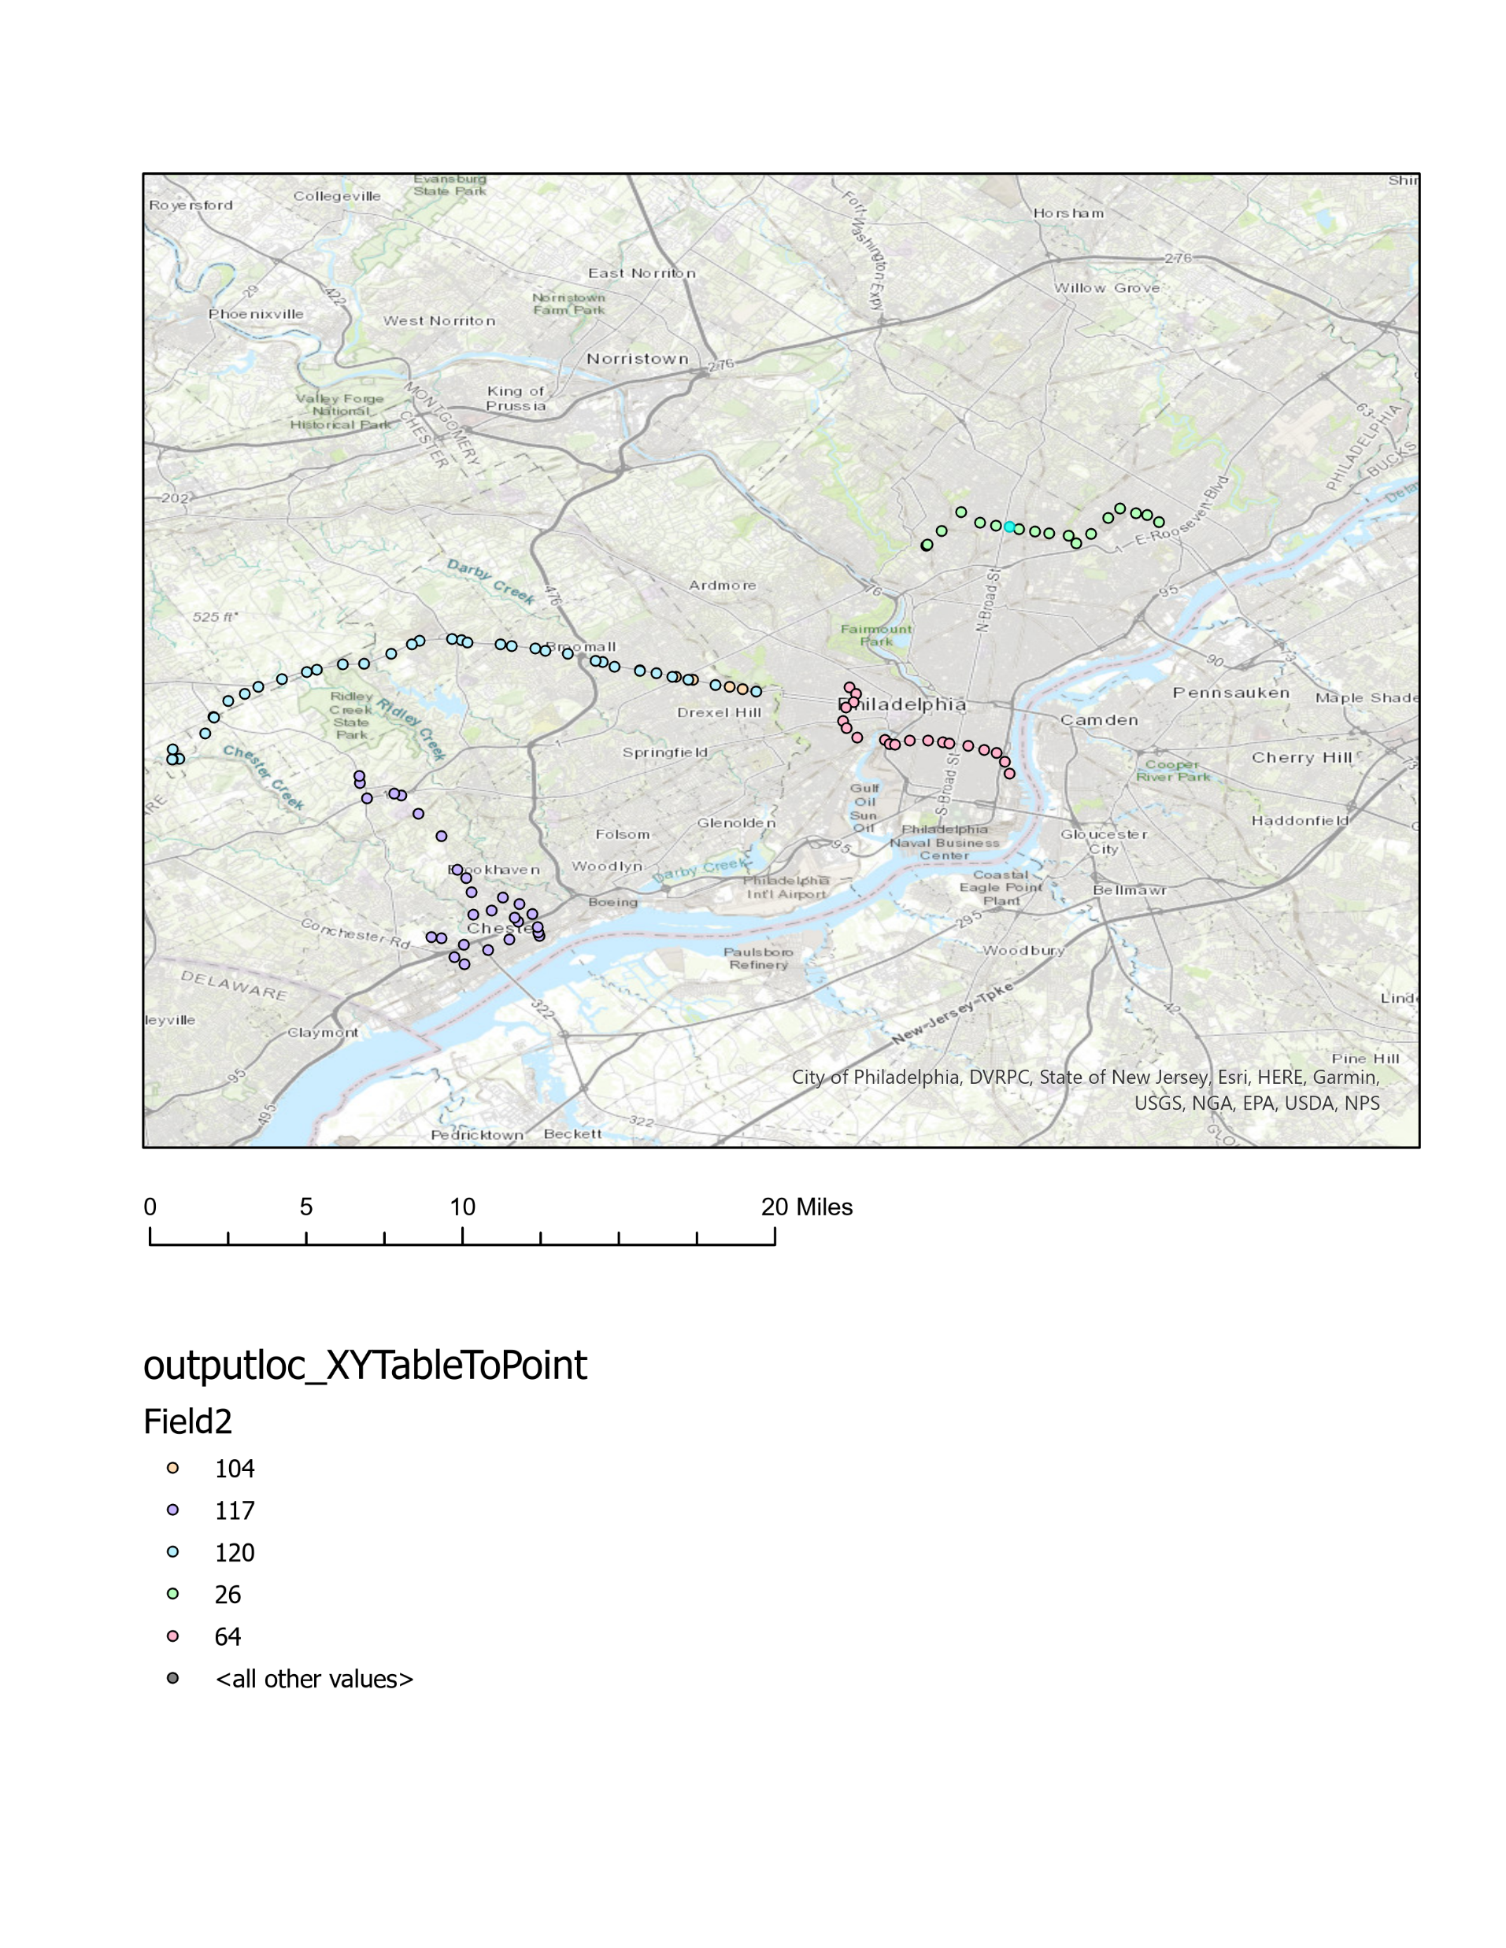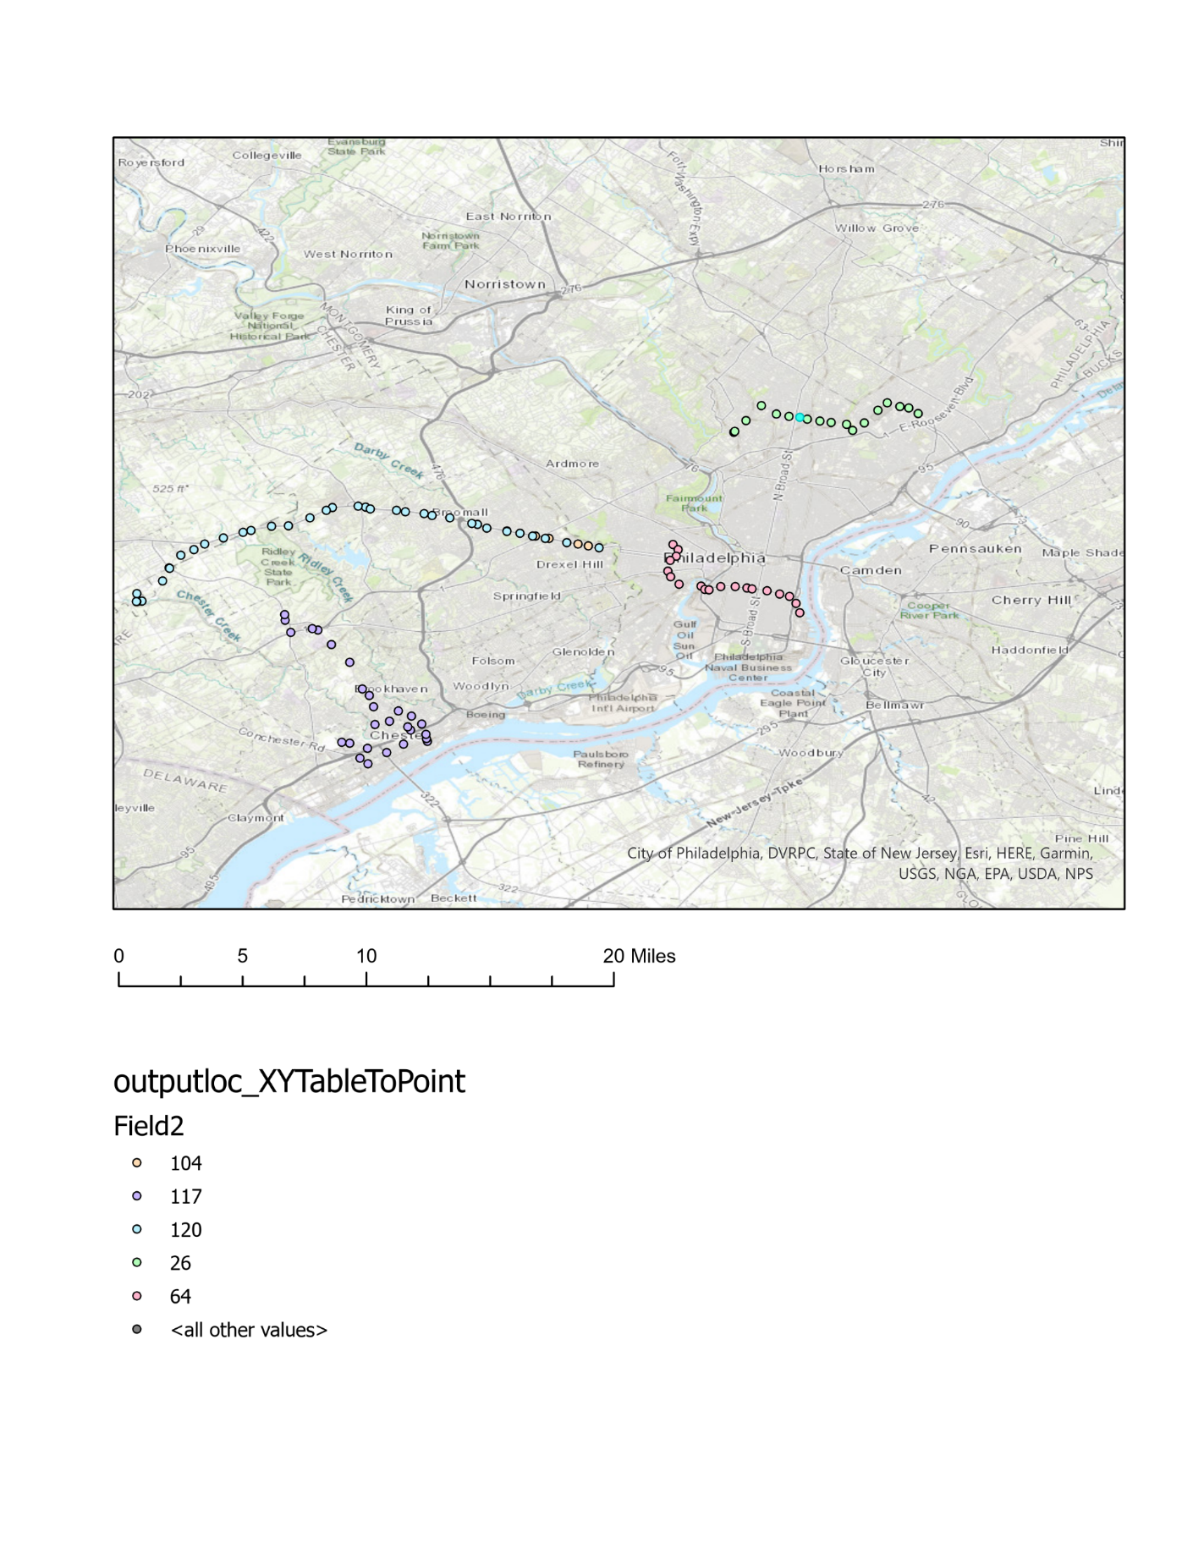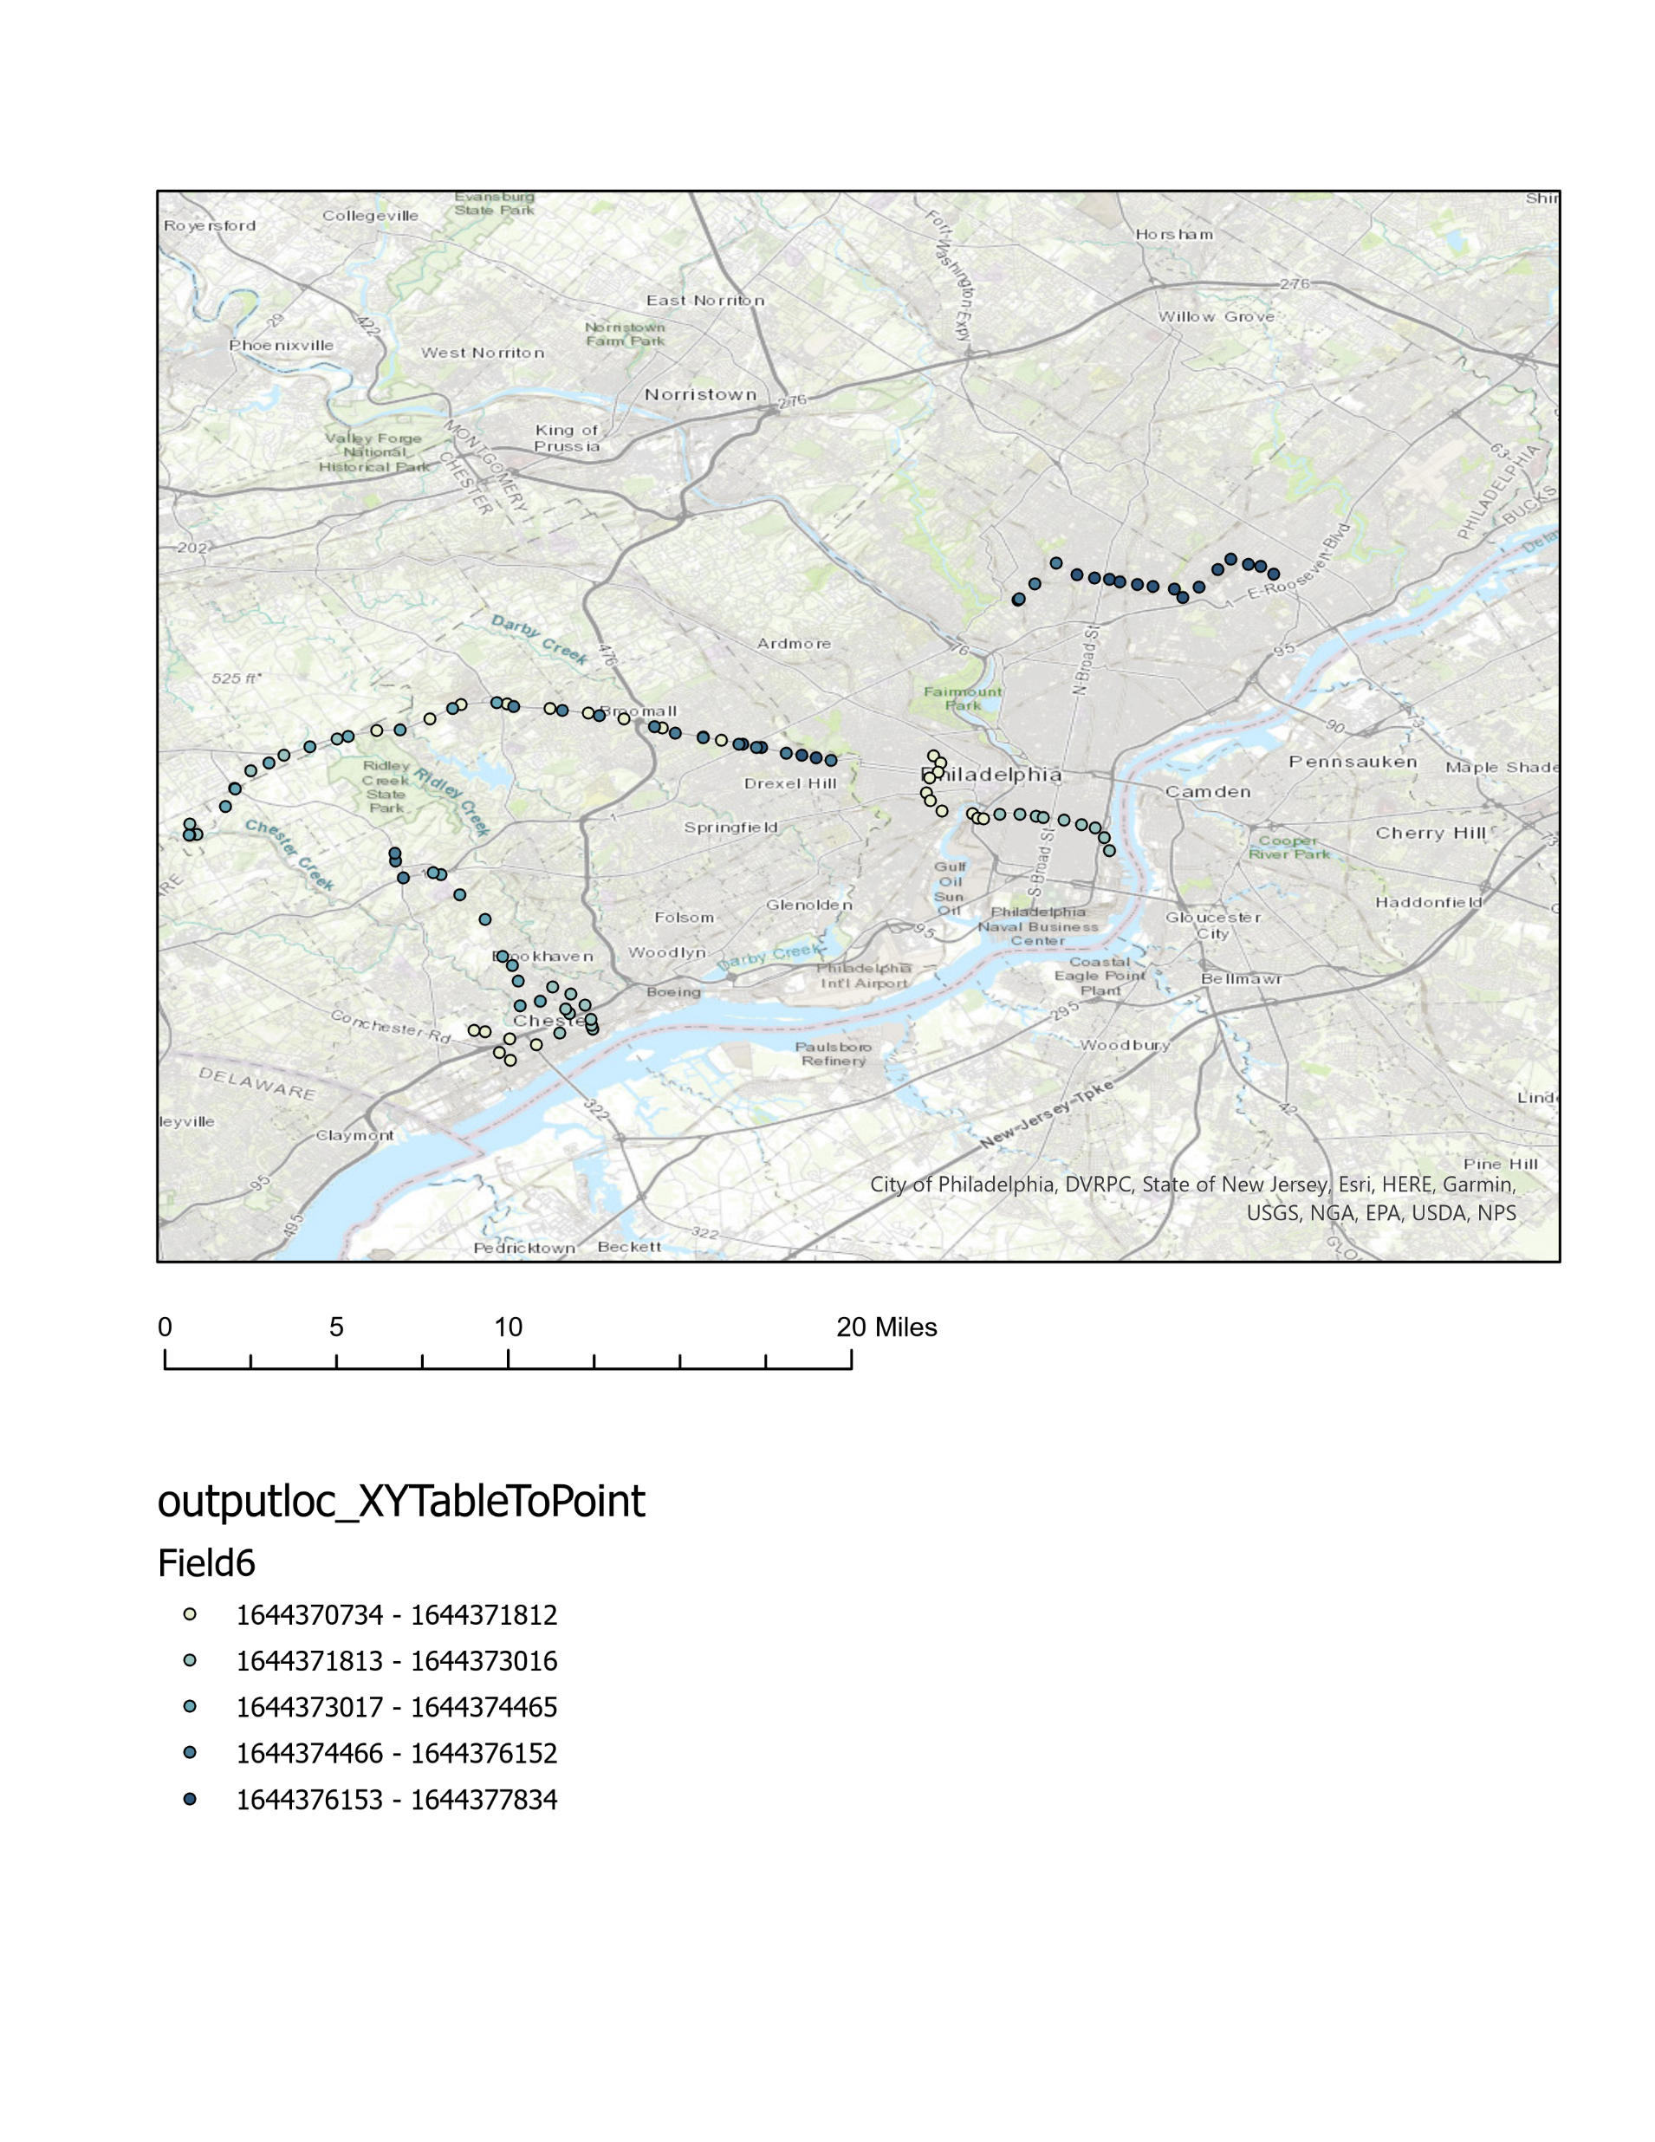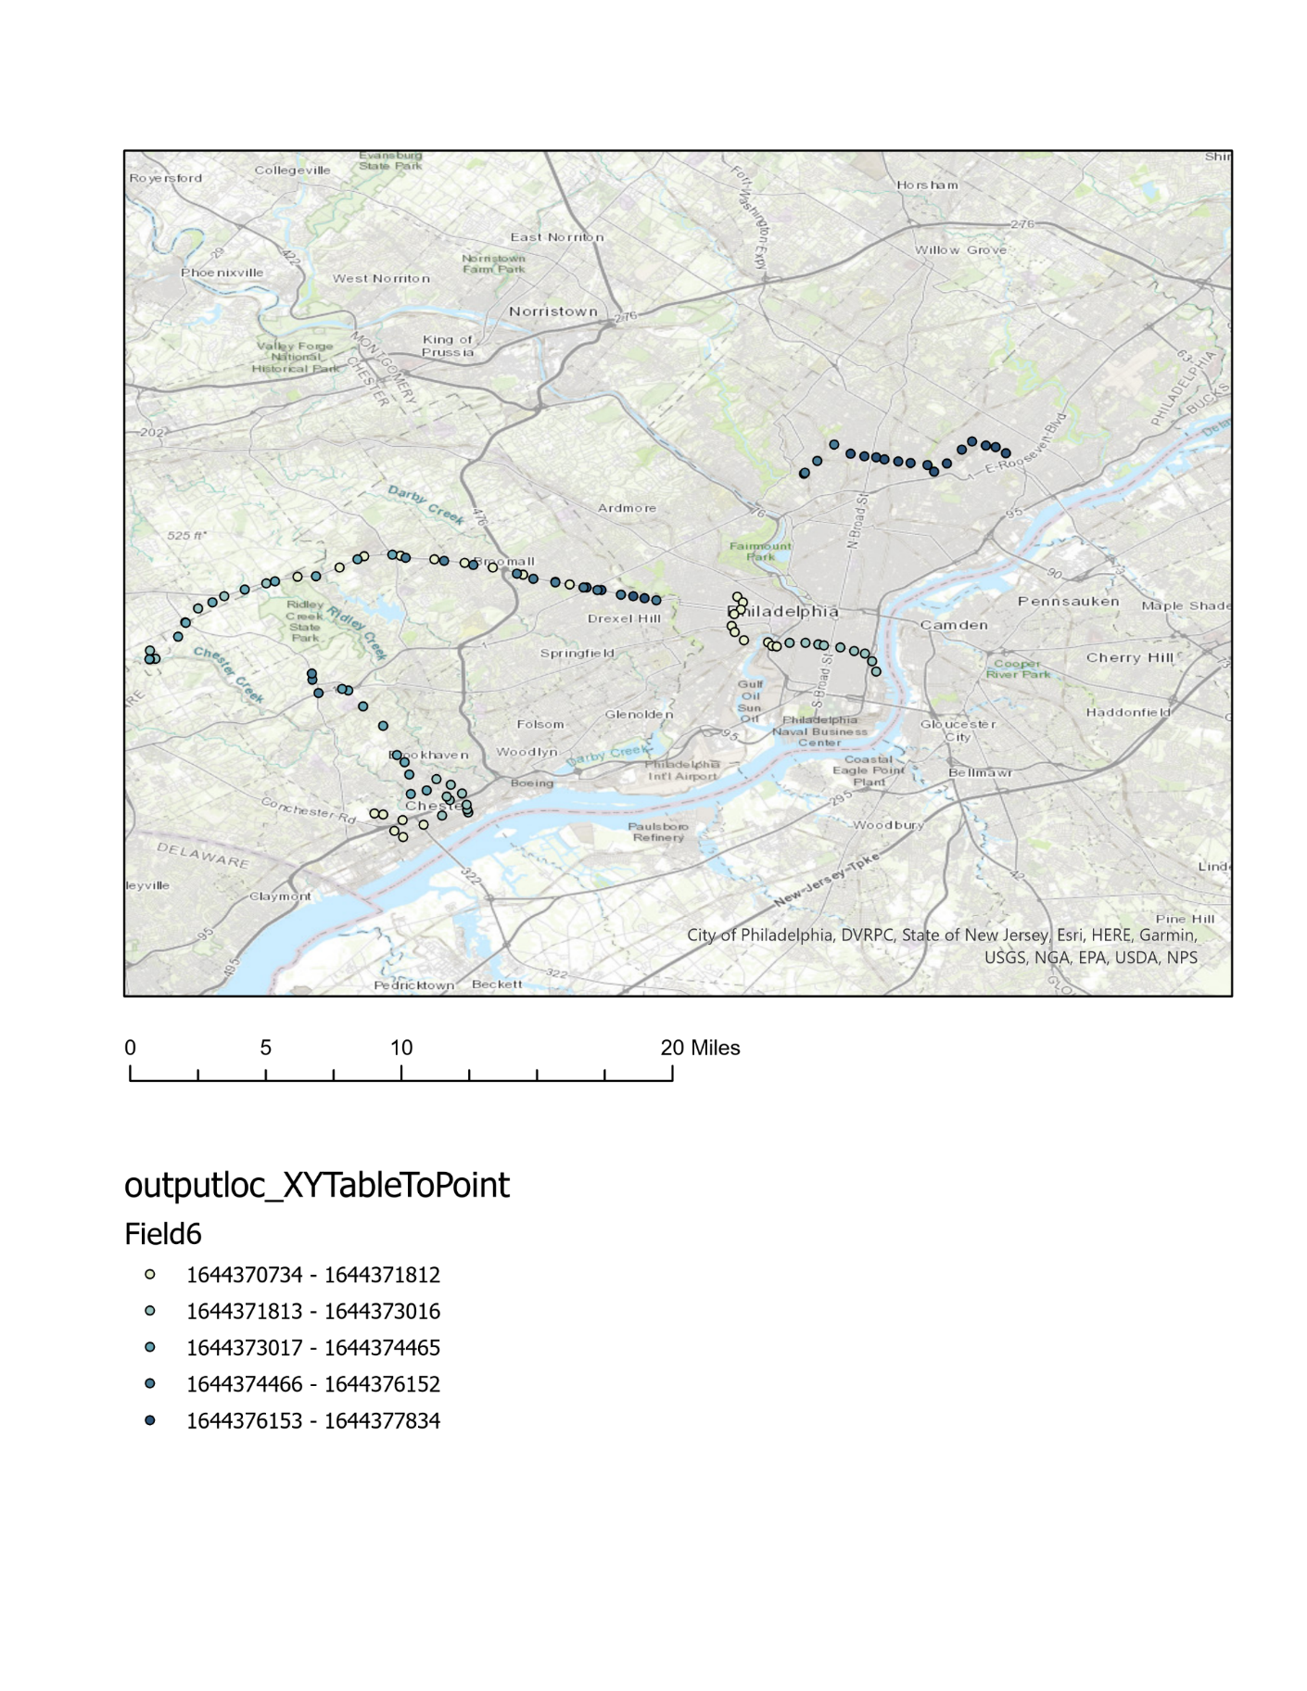

**Bus Route**

**Cancellation Time**

10:38 PM

9:38 PM

8:38 PM

Once more data is collected, all stops will be organized according to factors like ridership, bus frequency, population, one-car and no-car households, and traffic factors that may contribute to the kinds of situations that cause buses to arrive early or buses to be cancelled. There may be correlations between stops with increased rates of cancellation or early arrivals and those factors.

(Dashboard – still just thinking about for now)

Technical Implementation

Observations to this point come from four days of data scraping SEPTA’s internal real-time update data. The scraper runs constantly via a Python program which, once having been started, does not stop until completion after one month. The program loops through the SEPTA real-time updates, and records any stops having been reached early, as well as any stops on routes that were cancelled. It completes a loop once every two minutes, and writes its database to CSV files every 10 minutes.

The first CSV file, “all.csv,” contains data associated with each stop, organized in such a way to save space and be convenient for the Python program. The other two CSV files, “cancel.csv” and “early.csv,” hold formatted, ArcGIS-ready data associated with cancelled and early stops, respectively.

To best keep the program running without interruption, it has been running on an instance of an Amazon AWS EC2 virtual machine. This method was chosen due to its free cost and its intuitiveness in terms of performing virtual functions. The data are copied and pasted outside of the virtual machine before being accessed to ensure there are no permission issues with the program needing to access the csv files.

Currently, to look at the data in ArcGIS pro, I first load a shapefile of all SEPTA bus stops with their coordinates, as well as their IDs. I join the CSVs, and analyze accordingly.